SDR Sharp Lab Teacher Setup

* **Description:**
  + This document will explain the what is needed to be setup for the SDR Sharp Lab. In the 433MHz section of the lab, it can not be guaranteed if there are devices nearby for students to pickup so this guide will make a very simple device for students to pick up.
* **Objectives:**
  + Assembly circuit
  + Download Arduino IDE
  + Program Arduino
* **Materials:**
  + Windows computer with at least 8 CPU cores, 8 GB of ram, and 11 GB of storage
  + Arduino Uno kit (<https://www.amazon.com/ELEGOO-Project-Tutorial-Controller-Projects/dp/B01D8KOZF4/ref=sr_1_6?sr=8-6>)
    - Items needed in kit; Arduino uno, programming cable, jumper wire, and bread board.
  + 433MHz module (<https://www.amazon.com/QCCAN-Wireless-Transmitter-Receiver-Antenna/dp/B0BLTSSMXH/ref=pd_bxgy_d_sccl_2/136-8949012-1830723?pd_rd_i=B0BLTSSMXH&psc=1>)
    - Only the transmitter is needed
    - This kit includes antennas that can be soldered on to improve range. How to solder them on is outside the scope of this guide. Without the antenna the module will only have about a 5 ft range, so students may need to get close with there SDR’s to pickup the signal.
  + Internet connection or USB containing the following files
    - https://downloads.arduino.cc/arduino-ide/arduino-ide_2.3.2_Windows_64bit.exe
    - git repo location for arduino code

**Setup:**

1. Assemble the circuit bellow:

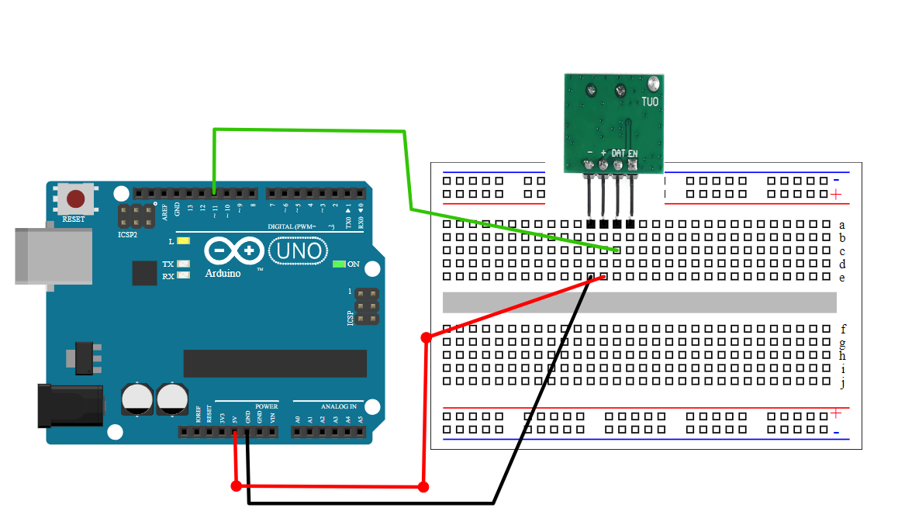

1. Install the Arduino IDE
2. Download the ino file from the github page listed in the material section
3. Open the ino file
4. Plug in the Arduino with the provided USB programming cable
5. In the Arduino IDE, click on “Select Board” then the “Select Other Board and Port”
6. In the window that pops up, in the search area for “Boards”, search for “Arduino Uno”. Select it and then select the port in the port section. If there are more than one port available, unplug the Arduino and re-plug it in to see what port disappears and then reappears. That is the port you need.
7. In the left menu bar, click on the symbol in the picture bellow that is circled in yellow.



1. In the menu that opens, search for “radiohead”. Your search results should look like the image bellow. Click on the box that says “Install” for the result that says “RadioHead by Mike McCauley”. The Image says “Remove” but that is due to it already being installed.

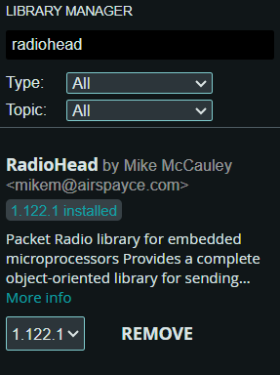

1. Once the library finishes installing, all that is left is to program the Arduino. Click on the right facing arrow in the top left of the Arduino IDE.



1. Once programming is complete, the Arduino should now start broadcasting a 433MHz message. You will need to keep the Arduino plugged into your computer so it remains powered on.